Issue 05 | September 24 2019

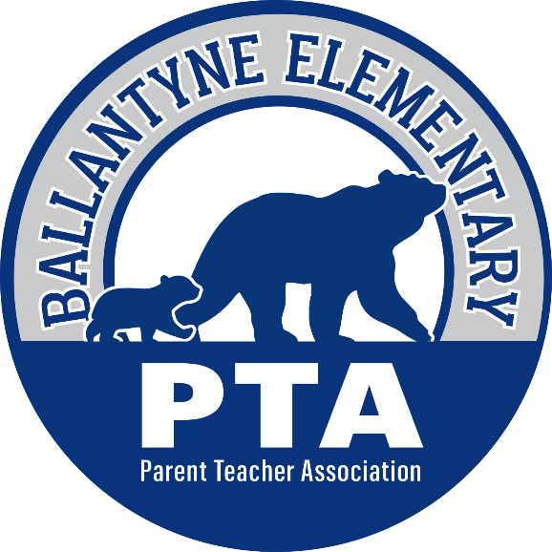

The Bear Blast

Welcome to the weekly PTA school newsletter – the best place to get the most up to date news and information for
Ballantyne Elementary School!

Upcoming Events

September 26th | Fall Picture Day for All Students  (click here for more information)
September 27th | 9:00 am - Principal’s Coffee in the Media Center  see below for more information
September 30th | Annual Campaign Fundraiser Kickoff  see below for more information
October 2nd | -National Custodian Appreciation Day - see below  -Walk or Bike to School Day - see below  -BBNO at Bamboo 7 Asian Cuisine – 4 to 8 pm
October 3rd | Fall Bookfair Previews for Kindergarten and 1st Grade
October 4th | Fall Bookfair Sales Begin  see below for more information

Are You Interested in the State of the School?

Then come to the first Principal’s Coffee of the year, this Friday, at 9:00 am in the Media Center. Principal Rogers will go over new and exciting changes to the school, updates to the curriculum and answer questions that you might have. This is a great way to meet other parents, ask a question or two and stay up to date on current events around campus. Parents are partners and we hope to see you all there!

It is Almost Book Fair Time!

Do your kids love shopping for new books at the book fair? Do they love benefitting from the programs and end of year books that we provide to each student as a result of the funds earned from the fairs?

In order for us to successfully operate our book fairs we need help from volunteers like you. Please look at the sign-up on the All PTA Sign-Up page of the website or click the button below and consider donating your time for our fall fair!

Due to our new 7-day specials rotation and lower than needed volunteer participation for past fairs, we are changing the format of the fair this fall. During the dates of the fair, media center specials classes will be held in the individual classrooms. Since student’s will not be coming down to the book fair during their media class time, the fair will be open to all students and families to shop every day before school and at appropriate times during the day with a pass from their teacher. Parents are welcome to shop at any time during the day or join their Bears before the bell rings, during the student’s lunch period, or during Curriculum Night on October 10th. Here is a quick schedule:

Wednesday October 2nd: 3:45 – 6:30 pm - Fair Setup
Thursday October 3rd: 9:00 – 3:00 pm – Previews for Kindergarten & 1st Grade Only
Friday October 4th: 8:00 – 2:00 pm – Sales Open
Monday October 7th: 8:00 – 2:00 pm – Sales Open
Tuesday October 8th: 8:00 – 2:00 pm – Sales Open
Wednesday October 9th – TEACHER WORKDAY - NO SCHOOL, FAIR IS CLOSED
Thursday October 10th: 8:00 – 2:00 pm for day sales & 5:30 - 8:00 pm during Curriculum Night
Friday October 11th: 8:00 – 2:00 pm – Sales Open, Fair Breakdown begins at 2:00 pm

The Annual Campaign Fundraiser is Almost Here!

We don't ask our families to sell wrapping paper, popcorn, cookies, or coupon books. We only ask for whatever monetary donation your family can give in support of the many programs, technology, materials and activities that we provide for your students here at Ballantyne. In other fundraisers the school receives only a portion of the donations, for this campaign all funds go directly to the school!

Here is a snapshot of the major projects your donations supported last year:

Here is what we can do this school year, with this fundraiser alone, if we reach our campaign goal:

Remember, we are a 501(c)(3) Non-Profit Charity and many of your employers will match your donations to the PTA. Please click here to learn how to “double your donation”! Once those matches are approved, make sure you send proof to ballantyneptatreasurer@gmail.com
so they can count for your student towards incentives.

Next week we will reveal our fun campaign incentives for the school if we reach our various giving levels so stay tuned!

Celebrate our Custodians!

On October 2nd we will be celebrating Custodian Appreciation Day! It would be wonderful if your Bear could send in a thank you note for our amazing custodial team – Mr. English, Ms. Frias and Ms. Wilson. They are really the unsung heroes of the school, quietly working behind the scenes doing jobs that no one else would want to do in an effort to make our days better. Let’s show them how much we notice and appreciate their work!

Make sure that anything you send in is addressed to the custodians so we can get them the thanks they deserve!

International Walk or Bike to School Day is on Wednesday, October 2nd
Safe Kids Charlotte Mecklenburg and Blaze the Fire Department Mascot have agreed to add to the enjoyment of our walk to school day this fall!

October 2nd is the big day. Families are invited to walk or drive from your home and gather at the entrance to the Legacy Apartments. Arrive by 8:10am at the corner of Landing Place Lane and Lancaster Hwy to participate and we will cross together (with police support for safety!) Blaze will greet the kids at school and we will have fun treats thanking them for trying walk to school day.

For families wishing to gather for the walk to Legacy Apartments, the suggested meeting & parking places are Elevation Church and the Providence Point Clubhouse. Leaving those sites at 8:00am should get you to the apartments to be assisted across the street with the group at 8:10am.

We look forward to Walk to School Day and thank our community partners for their support.

Would You Like to Save a Tree Today?

We know that there is a lot of paper that is used in our school every day but we feel that we can all do our part to save a tree or two now and again. That is why, this year, we are making a concerted effort to reduce the number of flyers that are coming home with your students. In their place there are several methods that you can use to get your information:

- The Bear Blast - you have done it! If you are reading this you already have taken the first step to get your news and information without wasting resources – thank you! If you know anyone that does not receive our newsletter please direct them to the home page at www.ballantynepta.com where they can sign up.

- Social Media – our website, Facebook page and Twitter accounts are always current with the latest information. If you check them regularly you will get your news without having to sort through and recycle all of those flyers! Our Facebook and Twitter links are at the bottom of every Bear Blast.

- peachjar flyers – this handy website is how the school is now distributing many of the community flyers that would usually come home in Tuesday folders. The website even keeps track of how many trees we are saving by making this simple change!

Please click here to go to the peachjar website where you can see all of the current flyers or sign up to be notified each time a flyer is posted by the school. You can also access peachjar from the BES school website as well as the Ballantyne PTA website.

Register for Clubs!

Fall clubs have started and registration is now open for all offerings! Make sure you visit the “Clubs” page on www.ballantynepta.com to find out more information and to register before it is too late!

Order Your Spirit Wear Today!

Remember to head over to our new online store to purchase your BES gear!

Time to Relink!

Relink your store loyalty cards by clicking the button below.

Sign up to Paint the Birthday Rock!

Do you want to celebrate your BES Bear by painting a special birthday message on the rock closest to the school? If so, then for only a $5 donation you can sign-up to paint the birthday rock!

On the Birthday Rock page of BallantynePTA.com you can see all of the Frequently Asked Questions about painting and payment as well as find the link to sign-up!

FROM AROUND THE BEAR CAVE

Here are a few of the fun things that happened to our Bears this past week!

Our 4th and 5th Graders got to have a meet and greet with Scott Reintgen, author of Saving Fable.
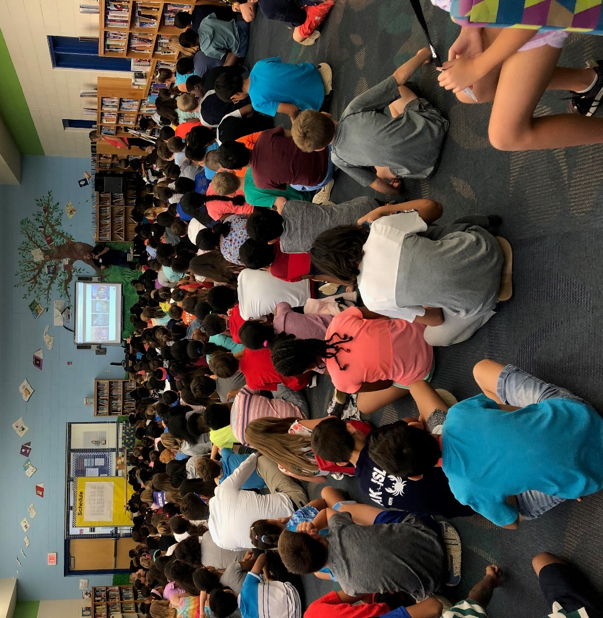

Our 4th grade students went on a fun field trip to Camp Thunderbird!
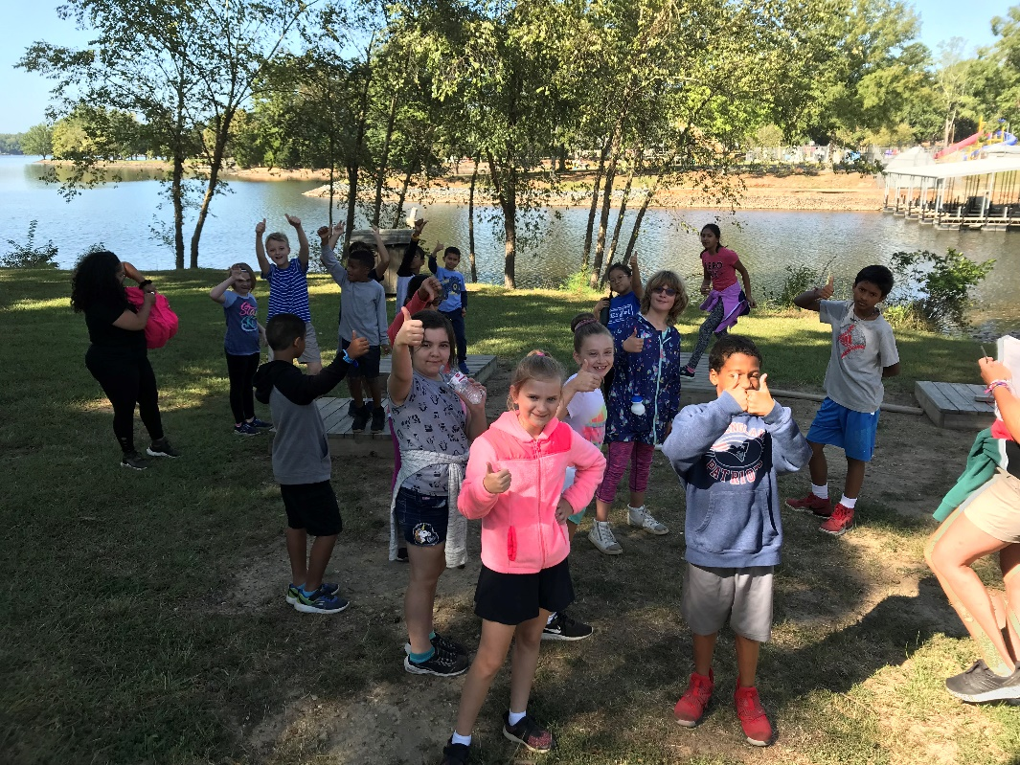

Our entire 3rd Grade Team went to Atlanta to study at the Ron Clark Academy. These leaders can now take what they learned and bring it back to the teachers at Ballantyne to positively impact the way that every student is taught. This professional development opportunity was sponsored by the PTA and YOUR donations – thank you!

IMPORTANT REMINDERS

If you are looking for information on transportation, visitation or dismissal please see the Important Reminders section on the Bear Necessities page of the PTA Website.

Stay Connected

Ballantyne Elementary PTA | 15425 Scholastic Drive, Charlotte NC 28277
Summer Rogers, Proud Principal | 980-343-0413
Bell Schedule 8:45 am – 3:45 pm

www.ballantynepta.com

ballantynelementaryschool.wearecms.com

Brought to you by Ballantyne PTA Communications – for questions please email ballantyneptacommunications@gmail.com

You are receiving this email because you subscribed to the ListServ. Would you like to unsubscribe from this list?
Click Here

