Issue 02 | September 3 2019

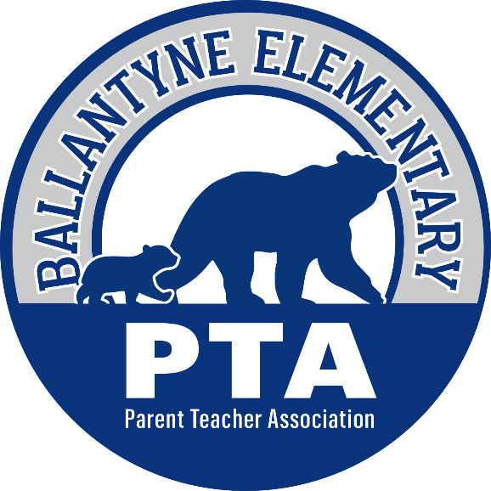

The Bear Blast

Welcome to the weekly PTA school newsletter – the best place to get the most up to date news and information for
Ballantyne Elementary School!

Upcoming Events

September 4th & 5th | Bears Night Out – Burger 21 from 5-9 pm
September 5th | 6 pm - Boy Scout Information Meeting
September 9th | 6:15 pm - Girl Scout Information Meeting
September 12th | 5:30 pm - Watch Dogs Information Meeting  6:30 pm - PTA Welcome Meeting
September 13th | 8 am - Character Bear Awards  BES Spirit Day – Wear Your favorite BES shirt!
September 18th | 7:15 am - School Leadership Team (SLT) Meeting  (see below for information on joining SLT)
September 19th | 4:30 pm - Room Parent Meeting Choice #1
September 20th | 9:30 am – Room Parent Meeting Choice #2

IMPORTANT REMINDERS!

- Visitors - Parents, grandparents, and visitors are required to sign in at the front office and show a photo ID every time they visit BES. This is true for picking up a child, eating lunch with your child or attending any school events.

- Safe School Policy - Beginning the first day of school, students must walk independently to class. If a parent is walking their child up to the building, a staff member will greet them at the doors near the front playground. We will welcome your child into the building and assist them with any needs they might have. Thank you for following CMS policy and keeping our school safe!

- Paperwork - We know this is a hectic week! Tons of important paperwork will go home with your child in their Blue Folders. Please read, take the required actions or complete these forms and return them to school ASAP.

- Traffic Pattern - Our drop off and pick up traffic patterns will remain the same as last year. Please remember that it is a ONE-WAY traffic pattern. If you are coming off Lancaster Highway, the traffic pattern will take you all the way around the back of the school before you will pull into the parking lot for drop off. If you are coming off Marvin Rd./Great Future Drive, you will turn right onto Clems Branch Dr. to proceed behind the school and into the parking lot for drop off.

- Walkers & Bike Riders - If your child is a walker/biker then you must complete a walker form. If you are meeting your child to walk, you will meet across the street from the front playground. There will be staff to help you find the location. You will not come onto campus. In the afternoon, if you have indicated that your child will walk/bike home and someone is not there to meet the child by 3:45 pm, they will return to the school building. You must then come into the school by the front office to pick up your child. If your child is able to walk home alone a form must be turned in stating this even if they are walking with a sibling or a friend. Bike riders will not be permitted to bike home until 4 pm after the carpool traffic has cleared.

- Tardies - We know it is sometimes hard to readjust to a school schedule following the summer but please remember our bell time is 8:45 am. Student drop off will begin at 8:10 am each morning but NOT before. The tardy bell will ring promptly at 8:45 am. If your child is not in the building by the bell, parents must park and walk their child into the school. After buzzing in, the parent must sign the child in as tardy and then the child will receive a tardy pass and proceed to class.

- Eating Lunch with Your Child - Just like last year, parents will be allowed to eat with their children in the lunchroom beginning September 9th. This allows children to learn the lunch procedures for the year with their teacher and new class. If you need to drop off your student’s lunch, you will drop it off in the front office and it will be delivered to your child. You will not be permitted to deliver it to the lunchroom or classroom yourself.

- Classroom Observation - All classroom observations visits must be arranged with the teacher at least 2 school days ahead of the requested visit time. An administrator must be made aware of the visit and a BES staff member will accompany the parent throughout the observation. Visitors must follow the school safety policy and sign in with a photo ID to receive a visitor badge that must be worn for the right side of the chest for the entire visit.

- Transportation Changes - All changes in transportation MUST be in writing. We will not accept verbal changes from a student or a phone call. Please make sure to send written communication to your child’s homeroom teacher, the front office, and before/after care (if applicable) any time there will be a change. There are NO EXCEPTIONS to this rule.

Have you completed your PTA checklist?
In your students’ folders last week, you should have received a blue PTA checklist to help you start the year. You can scan the QR code on the form, type in the web addresses on the paper or click below for a list of digital links.
Help us help your child by:
- Becoming a member of the PTA – this does not require you to volunteer, it only gives you a voice and a vote at each of our general meetings. Become a member for only $10 per parent and let your voice be heard!

- Donating to our annual campaign – our fall fundraiser does not ask you to sell anything, we only ask you to give to show your support of what we do for your child every day at BES! “Giving is not just about making a donation – it is about making a difference” – Kathy Calvin

- General Volunteer Sign-Up – sign up once and hear about various opportunities throughout the year – only pick the events that fit into your schedule!

“Pop” On Over to Volunteer!
It is almost time for our very first popcorn Friday of the school year! On September 20th we need 5 more volunteers to come and pop popcorn for the entire school and staff. From 8-11am our volunteers are the most popular people in the school with the amazing smells wafting down the hallway – come join us for a few hours of fun and fellowship while giving back to BES!
For all other volunteer opportunities remember to visit the sign-up list page on The PTA Webpage

Register for Clubs!
Does your child love art, playing chess, music, languages, drama or sports? If so, then they can continue those passions through all of the various clubs offered before and after school at Ballantyne Elementary!
Please visit the “Clubs” page on www.ballantynepta.com to find out more information and to register before your child’s favorite club fills up!

Time to Order Spirit Wear!
It’s time to purchase your BES spirit wear for the new school year. This year, we are offering a wonderful new online school spirit store. If you were not able to visit us at the Back to School Bash to purchase a new shirt or you were interested in purchasing one of our other awesome options, click below!

First Bears Night Out (BBNO) of the Year!
What is Ballantyne Bears Night Out? BBNO is a set time that our amazing fundraising committee has set up where each restaurant gives back a portion of their sales to BES. Some vendors even give us extra rewards for highest class participation that goes to our fabulous teachers!

Our first BBNOs of the year are this Wednesday and Thursday, September 4 & 5, from 5-9 pm both nights. Make sure you tell them you are with BES and have your students place the sticker they receive on the chart next to their homeroom – the winning teacher receives a prize!

Time to Relink!
Did you know that every year you have to relink your store cards to Ballantyne Elementary for the school to continue to receive benefits? Head over to our Fundraising page and scroll to the bottom to get links to Publix, Harris Teeter and Amazon Smile.

Join the School Leadership Team!
Are you looking for a way to be more involved at BES? One of the most valuable opportunities for family engagement is the School Leadership Team (SLT). The SLT serves in an advisory role by supporting the principal, helping to set the mission & goals of the school, writing and overseeing the School Improvement Plan (which provides strategies for creating school and student success).
If you would be interested in nominating yourself for a two year term on this critical team click below before THIS FRIDAY, September 6th, for more information and to fill out the application - https://docs.google.com/forms/d/1fVf3G25kRAI9WwVxsZQ85EU4-1ixYOUEisxquhsst2w/edit?usp=sharing

Sign up to Paint the Birthday Rock!
Do you want to celebrate your BES Bear by painting a special birthday message on the rock closest to the school? If so, then for only a $5 donation you can sign-up to paint the birthday rock!
On the Birthday Rock page of BallantynePTA.com you can see all of the Frequently Asked Questions about painting and payment as well as find the link to sign-up!

Bookmark the PTA Website!
Save BallantynePTA.com on your home screen today and you will thank us tomorrow!

Enjoy easy access to important links, keep up with the school calendar, explore volunteer opportunities and so much more, with ease, from the palm of your hand!

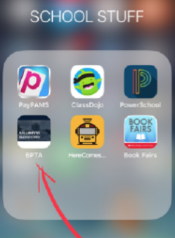

Stay Connected

Ballantyne Elementary PTA | 15425 Scholastic Drive, Charlotte NC 28277
Summer Rogers, Proud Principal | 980-343-0413
Bell Schedule 8:45 am – 3:45 pm

www.ballantynepta.com

ballantynelementaryschool.wearecms.com

Brought to you by Ballantyne PTA Communications – for questions please email ballantyneptacommunications@gmail.com

You are receiving this email because you subscribed to the ListServ. Would you like to unsubscribe from this list?
Click Here

