Issue 12 | November 12 2019

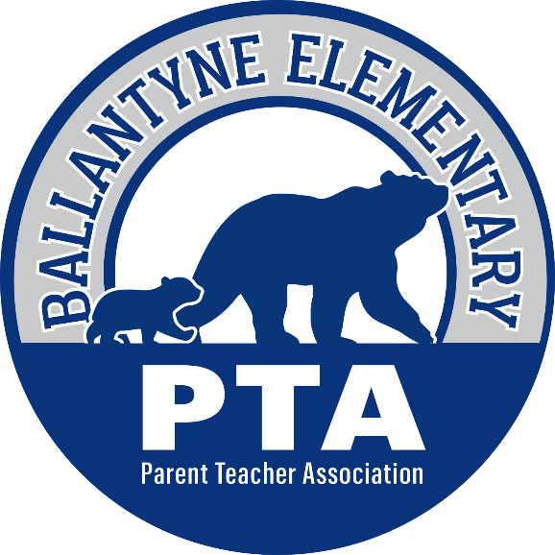

The Bear Blast

Welcome to the weekly PTA school newsletter – the best place to get the most up to date news and information for
Ballantyne Elementary School!

Upcoming Events

November 12th -15th | School Psychology Awareness Week – this week, remember to appreciate our school psychologist, Ms. DeBartolo, for everything she does to promote a healthy environment at Ballantyne!
November 14th | -Teacher Treats – It’s “Souper Chili” Outside -see below  -Mother-Son Glow Fun – 6:45 to 8 pm -see below
November 15th | -Character Bear Assembly – 8 am  -Popcorn Friday – help still needed, click here!  -BES Spirit Day
November 20th | School Leadership Team Meeting – 7:15 am – all are welcome!
November 21st | -Friends & Family Thanksgiving Lunch -see important information about tickets and timing below!  -BBNO at McAlister’s Deli (by Sprouts) from 5-9pm
November 22nd | -Principal’s Coffee – 9 am  -PTA General Meeting – 10 am
November 27th – 29th | NO SCHOOL – THANKSGIVING BREAK

It is Time for the Second Teacher Treats of the Year!
This Thursday, November 14th, our Hospitality Committee will be hosting the next “Teacher Treats” of the year and they need your help to make it a success!

What is “Teacher Treats”? Teacher Treats is a monthly themed event of refreshments and snacks provided by our generous families to show extra love to our teachers and staff during their lunch time and throughout the day. Each grade is assigned one month for their families to supply the treats but the entire staff gets to enjoy the event each month. We encourage you to sign-up to bring items during the event that corresponds to the grade(s) of your student(s) but feel free to sign up for any event that fits your schedule or fancy!

Click here to go to the All PTA Sign-Ups website page where you can see a list of each event, what grades are assigned to which month and the links to sign up! Our next theme is “It is Souper Chili Outside” where we hope to have a lot of soups and chili’s to warm up our staff as fall has finally arrived– we thank you in advance for your support!

Glow Fun Time for our BES Boys!
Also, on November 14th, we will be hosting our 2nd annual Mother-Son Glow Fun event! It was a very popular event last year so make sure you block your calendars now for a night of fun with your favorite little guy! See the flyer below for details:
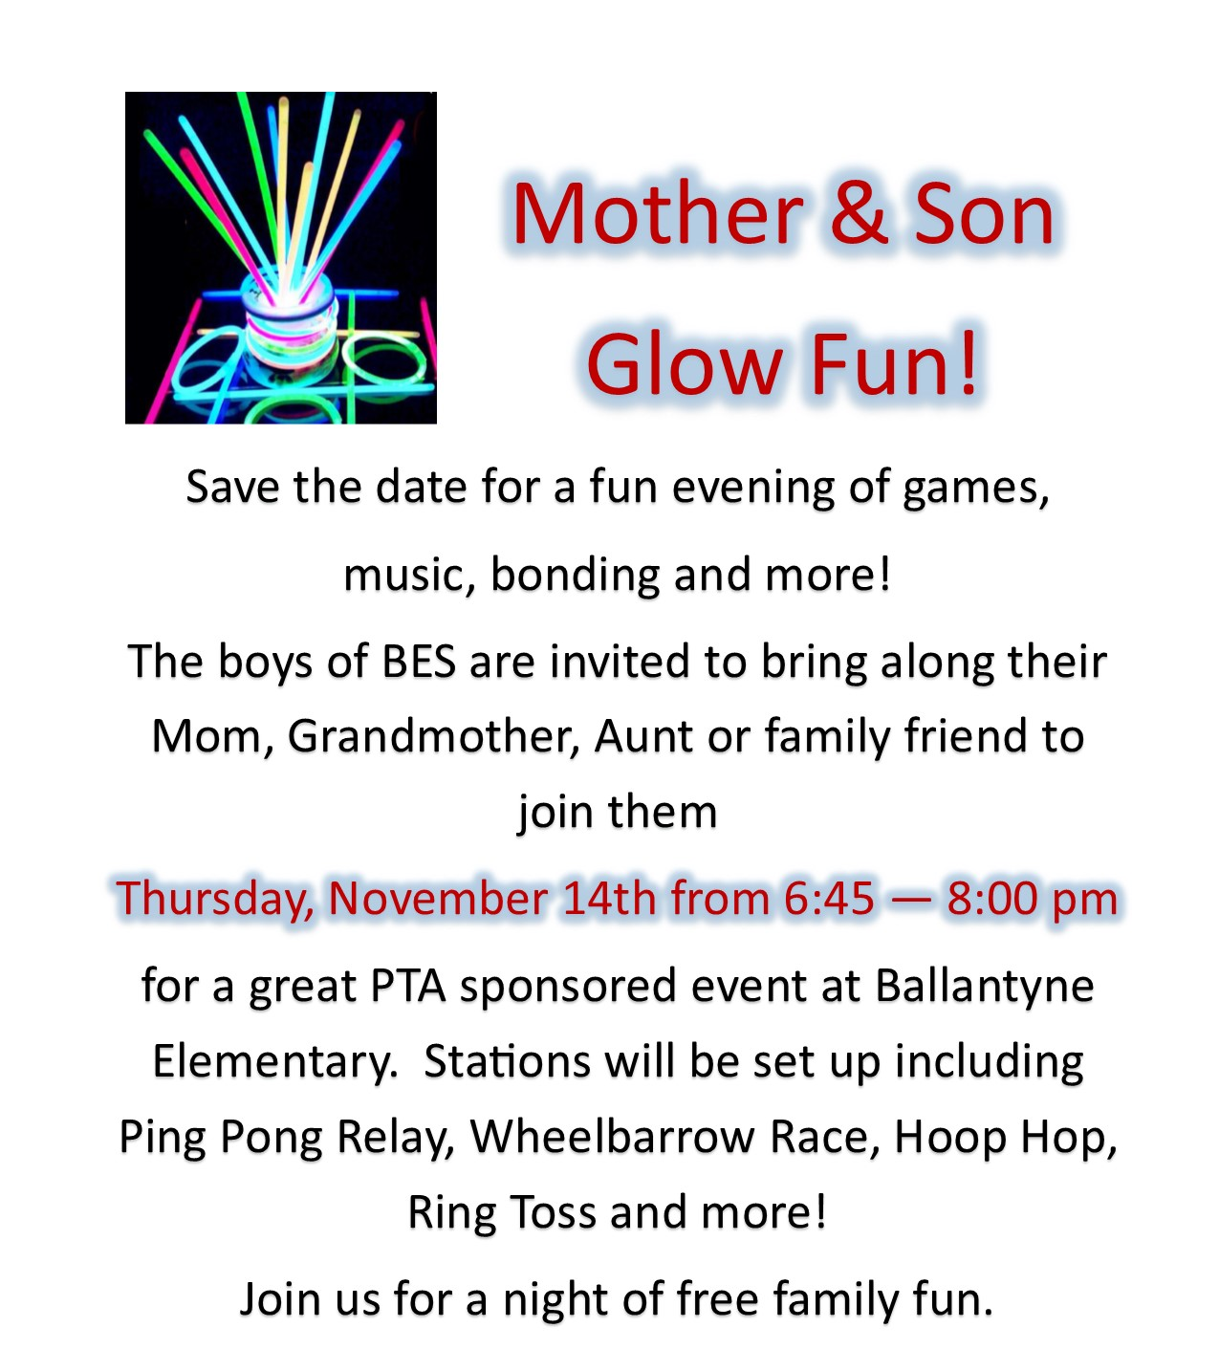
We also still need many volunteers to help make the event a success, please consider donating your time to help out!

Calling all 2nd – 5th Grade Singers for the Winter Program!
Does your 2nd – 5th grader love to perform? Would they like to sing in the Winter Program celebrating Cultural Diversity? If so, read below for a message from Ms. Derry!
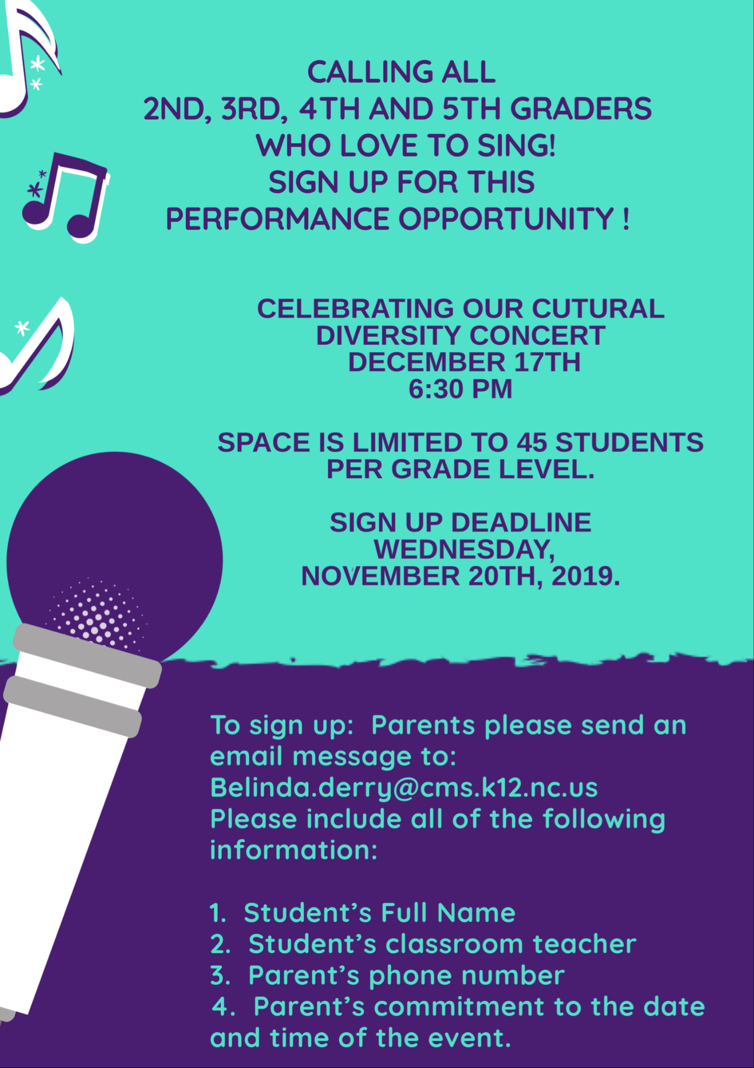

It is Time for the Annual Friends & Family Thanksgiving Lunch!
The annual Thanksgiving lunch is always one of the more anticipated events of the year. It is a time to take a break from your day to come enjoy spending time with your children while giving thanks for all that we have. Since the event is so popular, there special instructions in place, please read carefully!

Do me or my student have to participate? No, we always encourage our families to come and enjoy this special lunch their children but it is certainly not mandatory to buy the lunch or attend. Students without a family member in attendance will eat their lunch, either packed or purchased, in their classrooms at a “friendsgiving” event with their classmates and a fun movie!

Cost: $4.50 per adult. Adult tickets must be bought in advance – go to https://osp.osmsinc.com/CMS and select “Ballantyne Elementary” to find the Thanksgiving Lunch Adult Ticket item to add to your cart. Students can use their PayPams cafeteria accounts to buy their lunch and are charged the normal school lunch pricing.

Where: Ballantyne Elementary School Cafeteria

When: Thursday, November 21st, see times chart below:
Grade | Time
Kindergarten | 10:30 – 11:05 am
1st Grade | 11:05 – 11:40 am
2nd Grade | 11:40 – 12:15 am
3rd Grade | 12:15 – 12:50 pm
4th Grade | 12:50 – 1:25 pm
5th Grade | 1:25 – 2:00 pm

Special Instructions:
- Please arrive early for your scheduled lunch time as lines to check in will be long and we don’t want you to miss any lunch time with your student!
- If you are a registered CMS volunteer you will be able to shorten your wait by getting in the volunteer line that does not require a computer check-in. If you would like to register now to be a volunteer please click here.
- Make sure you have a photo ID – for the safety of our students NO ONE WILL BE ADMITTED WITHOUT A PHOTO ID.
- Make sure you buy your tickets beforehand – tickets will not be sold at the door
- After you check-in and receive a badge you will join our “waiting room” to await the appropriate lunch time to enter the cafeteria.
- As you can see, the lunch times are a bit longer to allow for longer lunch lines and to allow our students to enjoy more time with their families or with each other.
- There will be two lines in the cafeteria to get your lunch. By keeping these lines separate it will hopefully make the process smoother for all:
  - One line will be for families and their students so that you will receive your food and be able to sit down to eat together.
  - The other line will be only for students who will be sharing a “friendsgiving” lunch with their friends in the classroom while watching a movie!
- We need volunteers to help the check-in process go smoothly. Please consider signing up for a time that you are not at lunch with your student to help out!
https://www.signupgenius.com/go/805094eaba82cabfc1-thanksgiving

- See below for the formal invitation:

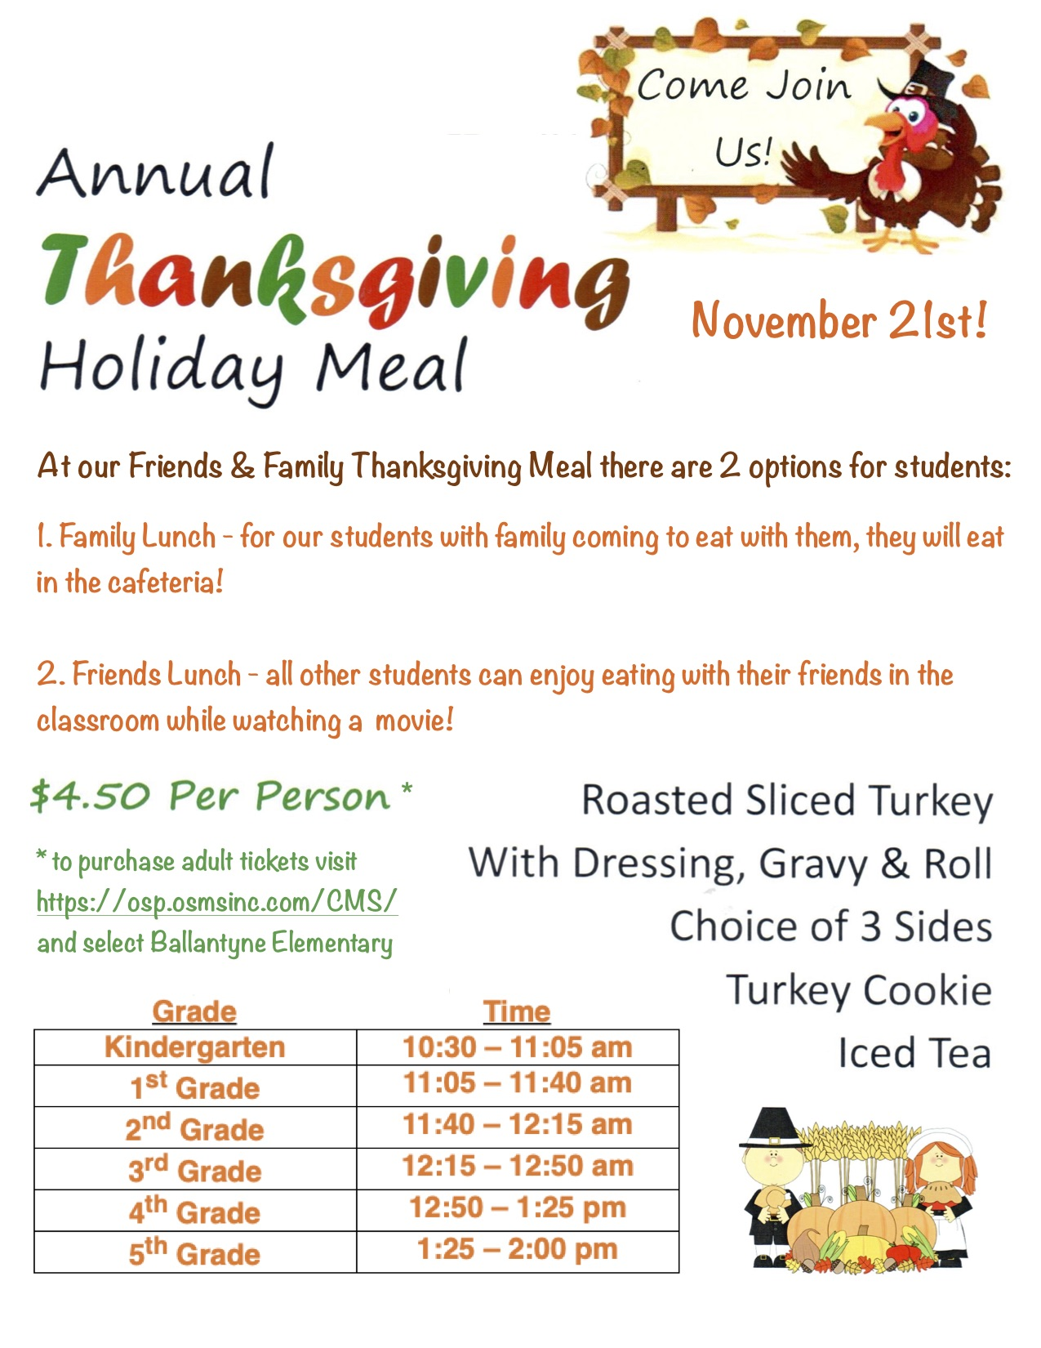

We hope to see you all there!

Help BES Give Back with the No Shave November Food Drive!
It is now November and the season of giving thanks. BES would like to give back by supporting the Second Harvest Food Bank of Metrolina through Friday, November 22nd.

Did you know that over 527,000 people, in the 19 North and South Carolina counties served by Second Harvest Food Bank of Metrolina, live in poverty – including 188,000 children and over 41,000 seniors. The Food Bank, which serves over 700 non-profit partners that include soup kitchens, emergency pantries, homeless shelters, senior programs, low-income daycares, veteran assistance organizations, and animal rescues, needs our help to help feed our hungry neighbors. Together we have the power to make a difference and connect those in need to the healthy and nutritious food they need to thrive. What a fantastic lesson being passed on to our students by participating in this drive.

Just as an added incentive to help our community, every day that we collect 300 cans of food, there are 4 of our male staff members who agreed not to shave their faces. Be sure to thank Mr. Morgan (3rd Grade), Mr. Butler (5th Grade), Mr. Ferreri (PE), and Mr. Greenwood (Dean of Students) for helping to inspire our students to grow their servant hearts!

On Monday, November 25th, the 4 classes with the most cans collected will get to choose a design for one of the staff member’s beards. On Tuesday, November 26th, the staff member will show his designed beard on the morning announcements. Start sending in those cans, Bears!

Fun Community Event Announcement!
A local Ballantyne Veterinary Clinic is hosting a fun event for kids that we thought might interest some of our students. See below for the flyer and click here for more information.
*please note that this event is not sponsored by BES nor the BES PTA

Digital Flyers on peachjar!
This handy website is how the school is now distributing many of the community flyers that would usually come home in Tuesday folders.
Please click here to go to the peachjar website where you can see all of the current flyers or sign up to be notified each time a flyer is posted by the school. You can also access peachjar from the BES school website as well as the Ballantyne PTA website.

Order Your Spirit Wear Today!
Remember to head over to our new online store to purchase your BES gear!

Time to Relink!
Relink your store loyalty cards by clicking the button below.

Sign up to Paint the Birthday Rock!
Do you want to celebrate your BES Bear by painting a special birthday message on the rock closest to the school? If so, then for only a $5 donation you can sign-up to paint the birthday rock!

On the Birthday Rock page of BallantynePTA.com you can see all of the Frequently Asked Questions about painting and payment as well as find the link to sign-up!

FROM AROUND THE BEAR CAVE

Here is one of the fun things that happened to our Bears this past week:

Last week, the PTA sponsored our first Cultural Arts assemblies of the year with the Golden Gates Russian Dancers. All of the students and staff really enjoyed themselves and we love that we can bring a love of the arts and cultural appreciation to BES using the generous donations of our families!

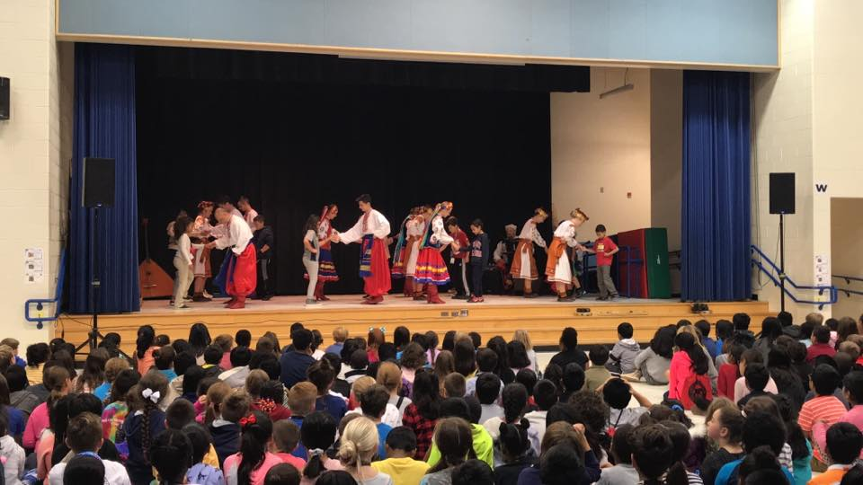

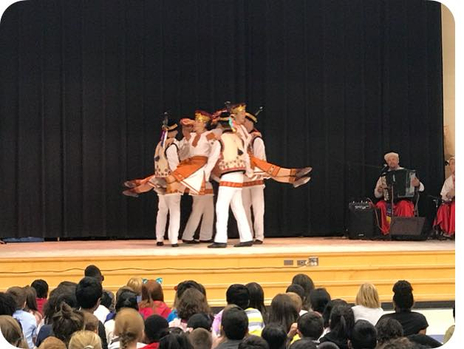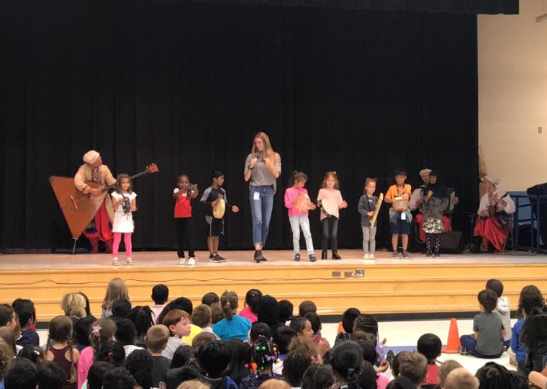

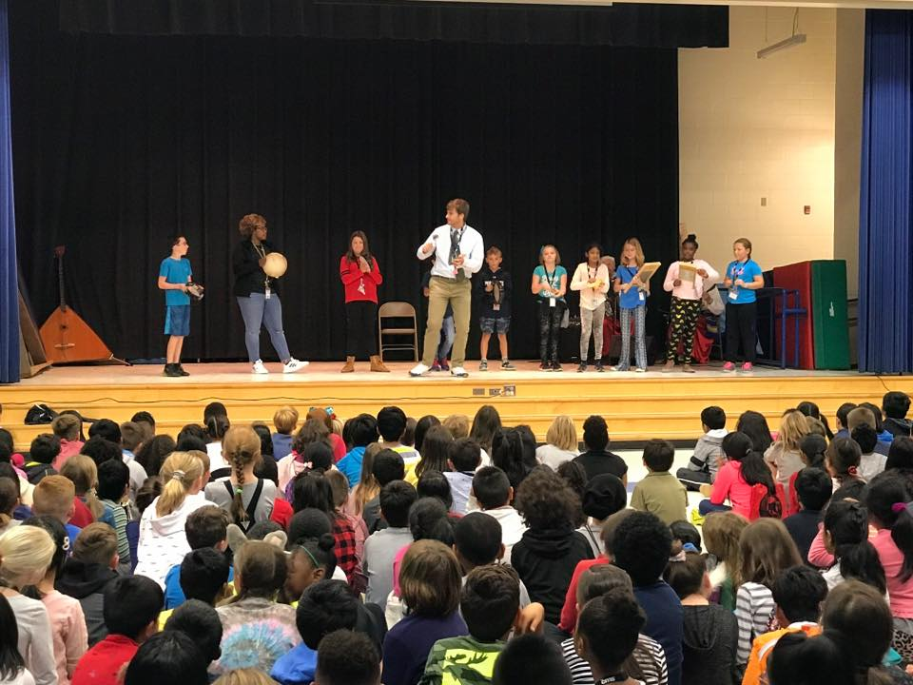

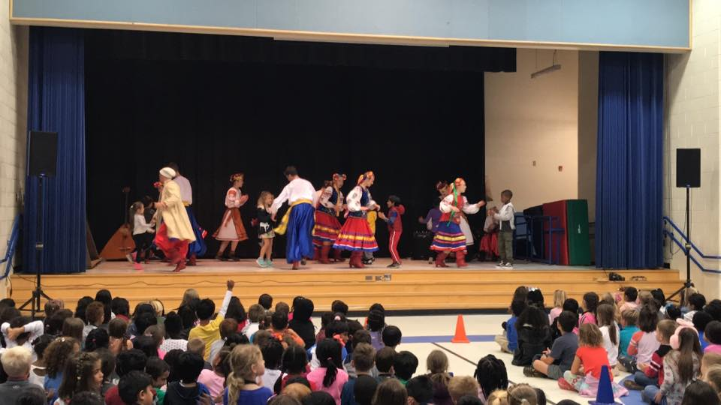

IMPORTANT REMINDERS

If you are looking for information on transportation, visitation or dismissal please see the Important Reminders section on the Bear Necessities page of the PTA Website.

Stay Connected

Ballantyne Elementary PTA | 15425 Scholastic Drive, Charlotte NC 28277
Summer Rogers, Proud Principal | 980-343-0413
Bell Schedule 8:45 am – 3:45 pm

www.ballantynepta.com

ballantynelementaryschool.wearecms.com

Brought to you by Ballantyne PTA Communications – for questions please email ballantyneptacommunications@gmail.com

You are receiving this email because you subscribed to the ListServ. Would you like to unsubscribe from this list?
Click Here

