Issue 10 | October 29 2019

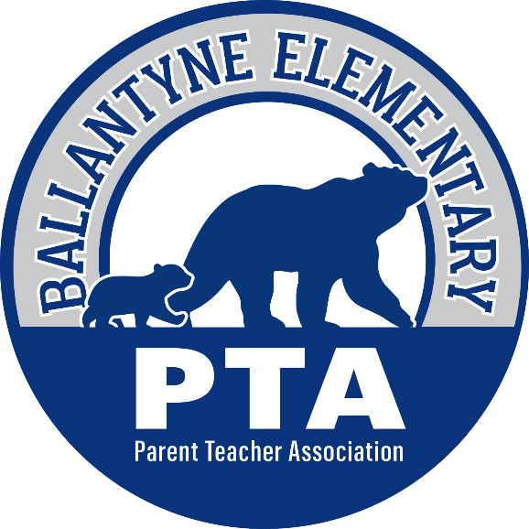

The Bear Blast

Welcome to the weekly PTA school newsletter – the best place to get the most up to date news and information for
Ballantyne Elementary School!

Your School Needs You!

This week’s edition of the Bear Blast is going to look a little bit different. Instead of highlighting all of the wonderful upcoming events that are happening at Ballantyne, this newsletter is going to begin with one final push for charitable giving so those events can continue to be a part of the educational experience provided here at BES.

As of today, the capital campaign fundraiser has earned $18,672 with only 33% of the BES families participating. This is only 328 of our students with a donation in their name and nearly 700 without. The goal for the fundraiser is 100% of families and $30,000. Without coming closer to that goal, many of the programs and resources that your family has come to depend on may not be able to continue and this Bear Blast will not be able to highlight all of the amazing events and ways that our students grow their brains each and every week.

Unfortunately, in a public-school, funding cannot always be provided for every need or skill that a child can use to grow and become a leader. Whether it is new technology, modern furniture, teacher training, advanced curriculum materials, or the recreational equipment and spaces needed to fuel bodies and brains. At Ballantyne, great value is placed on these needs and skills but the funding must come from each and every family who benefits.

Please take the time right now to click the button below and visit the capital campaign page on the website to learn more about what these funds support and then make your donations at www.pay4schoolstuff.com or send in your donation envelopes!

​

Thank you to all of the families that have already shown or will show their support for the top-notch education that students receive at Ballantyne Elementary – it is greatly appreciated!

Remember - we are a 501(c)(3) Non-Profit Charity and not only are these donations tax-deductible, many of your employers will match your donations! Please click here to learn how to “double your donation.” Once those matches are approved, make sure you send proof to ballantynepta@gmail.com so they can count for your student towards incentives.

The class with the highest participation rate is currently Ms. Haston’s 2nd Grade with 65% of the students donating – great job Team Haston!

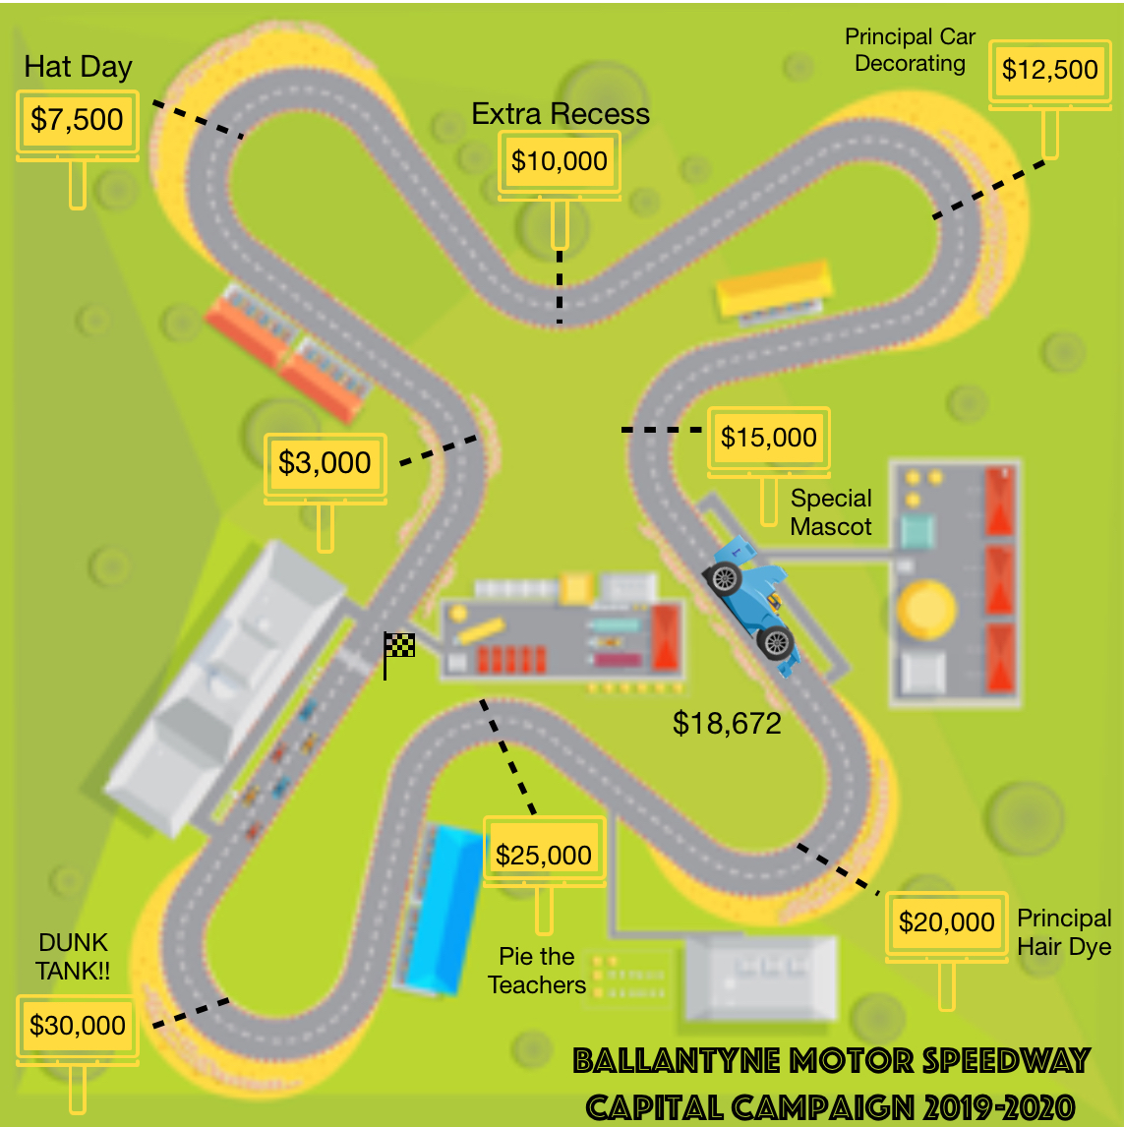

Upcoming Events

October 31st | -Dress Like Your Favorite Book Character – see below  -Fall Treats in the Cafeteria – see below
November 1st | -Annual Capital Campaign Fundraiser Ends  -BES Spirit Day
November 5th | No School – Election Day Work Day
November 6th | BBNO – Mod Pizza
November 8th | Stem Appreciation Day – time to appreciate our STEM facilitators Ms. Rivers and Ms. Farris!
November 14th | Save the Date for Mother-Son Glow Fun!

Be “Part of Our World” & Sign Your Rising Star Up for This Year’s Drama Club Production of…

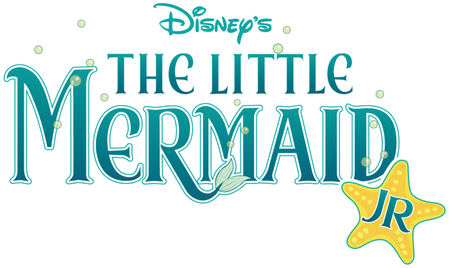
The Ballantyne Elementary Drama Club is a collaboration with the Morrison YMCA Ballantyne Arts Center. The rehearsal process utilizes an educational approach, providing theatrical training and direct application in a fun yet challenging environment. Professional directors, stage managers, and theatrical design teams support these quality productions featuring the young performers from Ballantyne Elementary School.
Drama Club begins Tuesday, November 7th and spaces fill up quickly – do not let your student miss out! Click below to go the PTA Website Drama Club page and sign up today!

No Tricks, Just Treats This Thursday, October 31st!
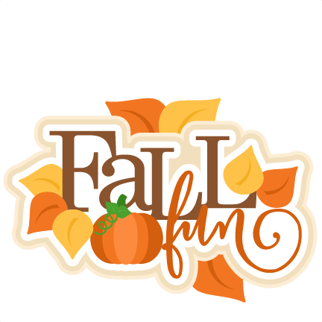
Before donning any costumes at night, our students are welcome to show us how much they love to read by dressing up as their favorite book characters! Make sure that all costumes are school appropriate and that your student brings the book in with them for any fun activities that their teacher might have planned!

To continue our day of fun, our students will celebrate the season with a special “Fall Treat” celebration in the cafeteria during their lunches. This celebration is for students only. If you have volunteered to provide a snack, drink or paper products make sure you send them in with your student or drop them off to the front office before 10 am. Thank you to all of our PTA Room Parents for helping us to coordinate this fun event!

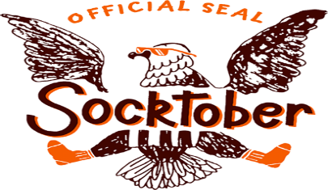

Help our Kindergarteners Give Back with Socktober!

Every night in the United States an estimated 600,000 people live on the streets. This October, SoulPancake and Kid President want 2 million people to prove that even the smallest acts of love, like donating a pair of socks, can make a big difference in the lives of our neighbors who are homeless.

Please help the BES Kindergarten Students take action against this problem!

Beginning Tuesday, October 16th through Thursday, October 31th, please donate a pair of new socks and place them in your classroom collection basket. If each student at BES donates just one pair of socks, we would collect over 900 pairs of socks! What a difference that would make in the lives of others!

Collection totals per grade-level will be announced each Monday on the morning news. The class in each grade-level that has collected the most socks for the week, will receive a giant sock award to post outside their classroom door. All socks will be donated to a local homeless shelter.

For more information regarding this national project, please go to http://soulpancake.com/socktober/

If you have any questions, please contact Lisa O’Herron at l.oherron@cms.k12.nc.us

Save the Date!
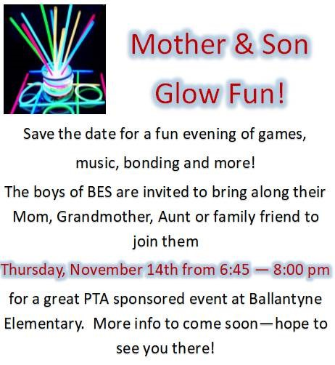

The Mother-Son Glow Fun is an event that does not charge admission and is one of the many events that the PTA sponsors 100% from your donations. To continue including events like this in your child’s educational experience make sure you click on www.pay4schoolstuff.com and donate today!

Stay Connected

Ballantyne Elementary PTA | 15425 Scholastic Drive, Charlotte NC 28277
Summer Rogers, Proud Principal | 980-343-0413
Bell Schedule 8:45 am – 3:45 pm

www.ballantynepta.com

ballantynelementaryschool.wearecms.com

Brought to you by Ballantyne PTA Communications – for questions please email ballantyneptacommunications@gmail.com

You are receiving this email because you subscribed to the ListServ. Would you like to unsubscribe from this list?
Click Here

